MiSACWIS Project

CM60 –View Case Workload Screen Specification

Version 1.11

September 25, 2014

Prepared for:


120 N. Washington Square
SACWIS Project, 3rd Floor
Lansing, MI 48933

Prepared by:

Revision Log
Version | Date | A/D/C (Add, Delete, Change) | Author | Document Section # | Description
0.1 | 08/02/2011 | A | N Page |  | Initial version
0.2 | 08/11/2011 | C | N Page | Several
0.3 | 08/15/2011 | C | N Page | 2.2  3.1.8 | Business Rule 9 corrected, 11 removed  Reference Values deleted
0.4 | 08/15/2011 | A | S Kulkarni | 3.1 | To Be Screen
0.5 | 08/16/2011 | C | S Kulkarni | 3.1 | Improved To Be Screen
0.6 | 08/17/2011 | C | N Page | 2.2  3.1.3 | Updates based on Session discussion
0.7 | 08/18/2011 | C | S Kulkarni  N Page | 3.1  2.2, 2.3, 3.1.5 | Modified To Be Screen  Updated based on DD Session discussion
0.8 | 08/19/2011 | C | N Page | 2.2  2.3 | Business Rule 7 set to “Delete”  Security Req 2 deleted
0.9 | 08/22/2011 | C | S Kulkarni  N Page | 3.1.2  3.1.3, 3.1.4, 2.2 | New To Be screen – xpand added and the confidentiality flag.  Business Rules and Buttons updated to reflected new expando
0.10 | 08/23/2011 | C | S Kulkarni  N Page | 3.1.2  3.1.4 | Updates based on Architectural Roundtable  Modified To Be Screen
0.11 | 08/23/2011 | C | N Page | 2.2, 3.1.2, 3.1.3, 3.1.4, 3.1.8 | Updated based on DD Session today  To Be Screen modified/screen fields values added
0.12 | 08/24/2011 | C | S Kulkarni | 3.1.2 | Modified To Be Screen
0.13 | 08/25/2011 | C | N Page | 3.1.2  3.1.2 | Field characteristics corrected  Modified To Be Screen  Field characteristics corrected
0.14 | 09/07/2011 | C | N Page | 3.1.2 | New To Be screen
0.14 | 09/07/2011 | C | S Kulkarni | 2.2 | Deleted Business Rule
1.0 | 09/07/2011 | C | N Page |  | Approved
1.1 | 09/08/2011 | C | Mike Stubbs |  | Quality Assurance Review:  Updated Class Attributes, To Be Type, To Be Calculations and UI Validations in Section 3.1.3.  No functionality impact. Updated information highlighted in yellow.
1.2 | 10/26/2011 | C | N Page | 1.1,  2.2,  2.3  3.1.8 | Change Control #:1416  Quality Assurance Review: No functionality impact.  Grid headers had “F.” where should have been “No.”. Corrected
1.3 | 11/03/2011 | C | N Page | 1.1 | Updated Purpose
1.4 | 11/16/2011 | C | S Kulkarni | 3.1.3 | Change Control #:1416  Quality Assurance Review: No functionality impact.
1.5 | 12/08/2011 | C | N Page | 3.1.4 | Change Control # 2375  Remove reference to “Prevention” use case
1.6 | 12/29/2011 | C | N Page | 3.1.2, 3.1.3  3.1.5, 3.1.8, | Change Control # 1635  Clarify Sort/Filter
1.7 | 12/29/2011 | C | N Page |  | Approved  All revisions accepted
1.8 | 01/16/2012 | C | N Page | 2.3 | Change Control #2808  Security grid
1.9 | 07/10/2012 | C | N Page | 3.1.2 | Change Control #13446
1.10 | 07/08/2014 | C | Mark Van Hoose | 3.1.2, 3.1.3 | Change Control # 60379 added Owner to S01.
1.11 | 09/25/2014 | A | Mark Van Hoose | 1.1, 3.1.2, 3.1.4, 3.1.5 | JJIMS Sprint 1, User Story 3

Table of Contents
1. Introduction 6
1.1 Purpose 6
1.2 Scope 6
2. Use Case Details 7
2.1 Action Buttons/Hyperlinks 7
2.2 Business Rules 8
2.3 Security Requirements 10
2.4 Screen Navigation 10
2.5 Tab Order 10
2.6 Pre-Conditions 11
2.7 Ticklers 11
2.8 Notifications 11
2.9 Calendar 12
2.10 Reports 12
2.11 Notes and Assumptions 12
3. Screen Details 13
3.1 View Case Workload Screen 13
3.1.1 As Is – View Case Workload Screen 13
3.1.2 To Be – View Case Workload Mock Up 14
3.1.3 Screen Fields 15
3.1.4 Action Buttons/Hyperlinks 19
3.1.5 Business Rules 20
3.1.6 Screen Navigation 20
3.1.7 Pre-Conditions 21
3.1.8 Reference Values 22

List of Figures
Figure 1 – As is -View Case Workload 13
Figure 2 – To Be – View Case Workload Mock Up 14

Introduction

Purpose
The CM60 - View Case Workload use case provides all MiSACWIS users who have assigned cases structured access to their cases. Users access the Case Workload page by, first, selecting the Case tab which by default presents the Workload page.

From the default view, user can determine case category (Investigation Cases, Ongoing Cases, and Permanent Ward), the number of assigned. The user can filter this view to be case category specific. In either scenario, the system will display a number reflecting the total number of cases assigned to the user. Each case displays the following summary information:

- Case Name (Case Reference Person’s name)
- Case ID
- Case status
- Case Assignment Role

By selecting the “Case ID” hyperlink, users will be presented with the Case Overview page for the case. Expandos to the left of each Case Name, when select display a list of all active case members. The names in the Case Members column of list are hyperlinks to each person’s Person Overview page.

Juvenile Justice workers will be able to print a caseload report.

Scope
The View Case Workload Use Case demonstrates the worker’s and/or Supervisor’s ability to view all Case Records to which they are assigned and to access each Case in order to maintain all work item tasks associated to the Case Record.

Use Case Details

Action Buttons/Hyperlinks
Status (Keep/Add/  Modify/Delete) | Label | Type | On Click Action/Navigation
Keep | Help | Hyperlink | Screen level Help appears in a separate browser window.

Business Rules
No. | Status (Keep/Add/Modify/Delete) | Business Rule Description | Modified Business Rule Description | Execution Event (field tab out/save etc) | Error Msg Code  To be completed by Development Team
1 | Modify | All cases where the worker has a non-end dated assignment will appear on the Case Workload page. | All cases where the worker has a non-end dated assignment will appear on the Case Workload page.  The user’s subordinates cases will not appear on this screen. | At refresh or screen load
2 | Modify | The System default is by alpha ascending order of the Case Last Name.  The “sort by” drop down will default to “All”. | The System default Case level sort is as follows:  Primary:  Investigation Cases  Ongoing Cases  Permanent Ward  Secondary:  Last name - ascending | At refresh or screen load
3 | Keep | When the user clicks on any expando link or image, the expando will either expand or collapse. |  | Click of the expando link or image
4 | Keep | Caseworker filter will default to the person that is logged in. |  | At refresh or screen load
5 | Keep | The display in the Case Member Table will display only active (open end-dated persons) case members.  The sort order of Case member is by CRP displayed first, then Date of Birth from the oldest to the youngest. Secondary sort will be in alpha order by last name, first name. |  | At refresh or screen load

Security Requirements
No. | Status (Keep/Add/  Modify/Delete) | Security Requirement
1 | Keep | Create  N/A
2 | Keep | Read  Foster Care Worker
3 | Keep | Update  N/A
4 | Keep | Delete  N/A
5 | Add | Juvenile Justice Worker - This security profile gives Juvenile Justice Workers ability to print their own JJ Caseload Report.

Screen Navigation
No. | Status (Keep/Add/  Modify/Delete) | To Screen Navigation Path
1 | Keep | From login screen Case tab defaults to workload page

Tab Order
No. | Status (Keep/Add/  Modify/Delete) | Screen name
1 | N/A

Pre-Conditions
No. | Status (Keep/Add/Modify/Delete) | Pre-Condition
N/A

Ticklers
Status (Keep/Add/Modify/Delete) | Tickler Name | Trigger Action | Tickler Generation Business Rule & Description | Tickler Removal Business Rule | Tickler Text
Status (Keep/Add/Modify/Delete) | Tickler Role
N/A

Notifications
Status (Keep/Add/Modify/Delete) | Notification Name | Trigger Action | Message Business Rule & Description | Message Text
Status (Keep/Add/Modify/Delete) | Notification Role | Trigger Action | Message Business Rule & Description | Message Text
N/A

Calendar
Status (Keep/Add/Modify/Delete) | Calendar Name | Trigger Action | Calendar Event Generation Business Rule & Description | Calendar Event Date and Time Business Rule | Calendar Event Text
Status (Keep/Add/Modify/Delete) | Calendar Role
N/A

Reports

Notes and Assumptions

Screen Details

View Case Workload Screen

As Is – View Case Workload Screen
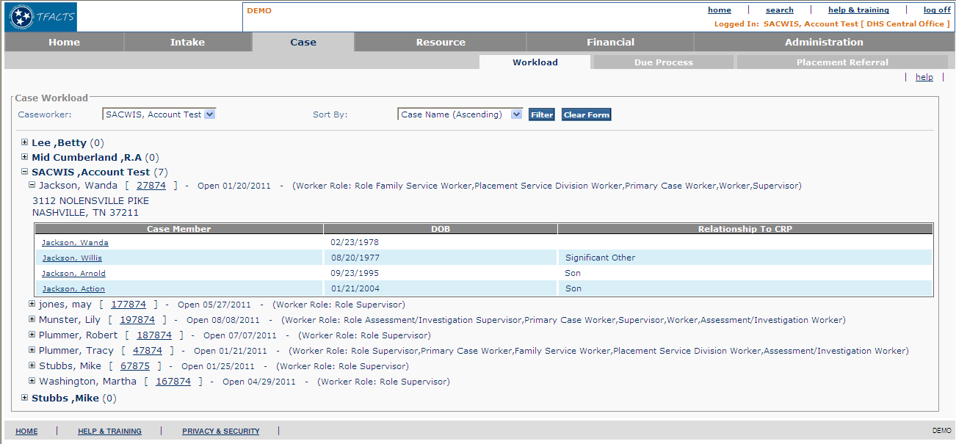
Figure 1 – As is -View Case Workload

To Be – View Case Workload Mock Up
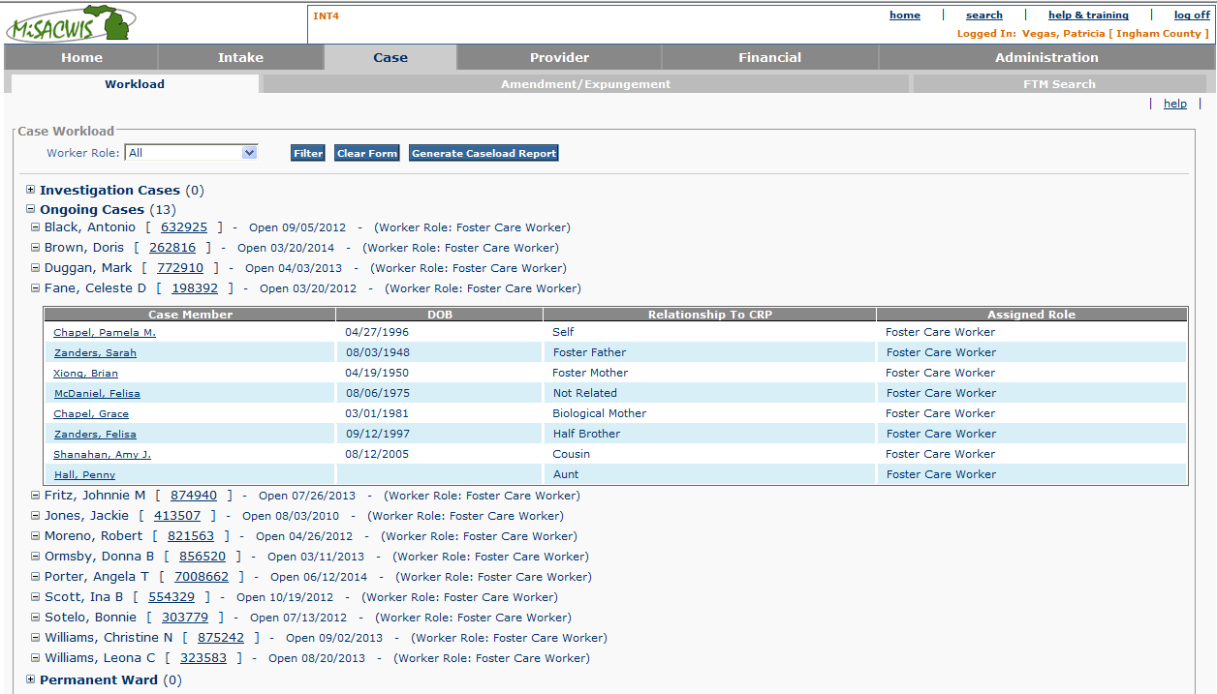

Figure 2 – To Be – View Case Workload Mock Up

    - Screen Fields
Status (Keep/  Add/  Modify/  Delete) | As Is  Class.Attribute Name | To Be  Class.Attribute Name | As Is  Display Name | To Be  Display Name | To Be  Type | To Be  Align | To Be Size | To Be  Read  Only | To Be  Calculation | To Be  Edit Mask | To Be  UI Validation
Keep | N/A | N/A | Case Workload | Case Workload | Display text | L |  | T
Delete | N/A | N/A | Sort by: | Sort by: | Display text | L |  | T
Add | N/A | Role.RoleName | N/A | Worker Role | Drop Down List | L | 100 | F | All the Roles for this user on the set of cases displayed |  | User Selected
Add | N/A | CaseCategory.caseCategoryCode |  | Investigation Cases  Ongoing Cases  Permanent Ward | Expando | L | 100 | F | System will group case assignment by Case Category code |  | User Selected
Keep | N/A | N/A | N/A | Case Count: | Display Text | L | 3 | T | To be calculated based on assigned open case count for each category of cases. |  | System derived
Keep | caseBase.caseFirstName + caseBase.caseMiddleName +caseBase.caseLastName | caseBase.caseFirstName + caseBase.caseMiddleName +caseBase.caseLastName | Case Name | Case Name | Display Text | L | 100 | T |  | Last name, first name middle name
Add | N/A | Intake.received_date | N/A | Complaint Date | Display Text | L | N/A | T |  |  | Only displays when Case Category is Investigaiton. Intakes are linked to Investigations through the Intake_Case_Link table.
Keep | CaseStatus.caseStatusCode | CaseStatus.caseStatusCode | N/A | N/A | Display Text |  | 30 | T |  |  | System derived  Only Display if Case Category is not Investigation
Keep | CaseStatus.caseModifiedDate | CaseStatus.caseModifiedDate | N/A | N/A | Date Field |  | 10 | T |  |  | System derived  Only Display if Case Category is not Investigation
Keep | Role.RoleName | Role.RoleName | (Worker Role: | (Worker Role: | Display Text |  | 100 | T | Use WorkAssignment Role.RoleId  And WorkAssignment. EmployeeID to determine the logged in worker’s work assignment role on this case
Keep | Use CaseParticipant.personID to get  Person.LastName + Person.suffixNameCode +Person.FirstName +Person.middleName | Use CaseParticipant.personID to get  Person.LastName + Person.suffixNameCode +Person.FirstName +Person.middleName | Case Members | Case Members | Display Text | L | 100 | T |  | Last name, suffix, first name middle name
Keep | Person.birthDate | Person.birthDate | DOB | DOB | Date | L | 10 | T |  | MM/DD/YYYY
Keep | WorkloadItemRelationship.relationshipCode | WorkloadItemRelationship.relationshipCode | Relationship to CRP | Relationship to CRP | Text  field |  |  | T | DomainCode=’Relationship’
Add | N/A | Role.RoleName | N/A | Assigned Role | Display text |  | 100 | T | Use WorkAssignment Role.RoleId  And WorkAssignment. EmployeeID to determine the logged in worker’s work assignment role for the case number |  | System derived

Action Buttons/Hyperlinks
Status (Keep/Add/Modify/Delete) | Label | Type | On Click Action/Navigation
Keep | Filter | Button | The Case Workload will be displayed based on sort selection
Keep | Clear Form | Button | Clears Filter
Keep | Expando on case name | Hyperlink | Expands the case name to include case member information
Modify | Case ID | Hyperlink | Depending on the Case Category, screen will navigate to appropriate Summary Page. If the Case Category is  - ‘AI’ the system should display IV20 – Maintain Investigation.  - ‘ONGOING’ the system should display CM02 – View Case Overview.  - ‘‘ADOPT’ the system should display the Adoption Overview on CM20b – Maintain Pre-Adoption Case
Keep | Link Person Profile (Case Member Name) | Hyperlink | The selected Person Profile will be presented, defaulting to the person Overview Basic page.
Add | Generate Caseload Report | Button | The caseload report will be generated in an Excel spreadsheet.

Business Rules
No. | Status (Keep/Add/  Modify/Delete) | Business Rule Description | Execution Event (field tab out/save etc) | Error Msg Code  To be completed by Development Team
1 | Add | If a worker has multiple roles on a single case then this hierarchy:  - Primary Worker  - Secondary Worker  - Courtesy Worker  Will be used to display next to the Case Name and ID.  For all other roles, select any.
2 | Add | The sort order of the Worker Role filter list will be:  - Primary  - Secondary  - Courtesy  - (All others)
3 | Add | If the user has security profile Juvenile Justice Worker in CM60 they will be able to generate their own caseload report. If the user does not have this profile, the Generate Caseload Report button will not display. | Upon load of the Case Workload screen.

Screen Navigation
No. | Status (Keep/Add/  Modify/Delete) | To Screen Navigation Path
1

Pre-Conditions
No. | Status (Keep/Add/  Modify/Delete) | Pre-Condition
1 | Keep | User must be an authorized MiSACWIS user

Reference Values
No. | Status (Keep/Add/  Modify/Delete) | To Be Class Attribute | Domain Code | Short Desc | Ref Data Code
1 | Add |  |  | All (default)
[These are all the roles for this user, for the set of cases displayed.
Sort: ;
- Primary
- Secondary
- Courtesy
- (All others)

